UNLOCKING POTENTIAL  TRANSFORMING LIVES |  | 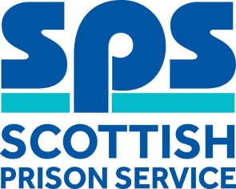

JOB DESCRIPTION & PERSON SPECIFICATION

Job Details
Job title | Report to
General Administrator | Business Improvement Manager
Location | Department
Barlinnie | Finance
Hours of work | Number of hours
Normal Office Hours | 35
Job role status | Is C&R/PPT a requirement?
Non-Operational | PPT
Pay band | Does this role attract any additional allowances (e.g. on-call allowance, RRA)?
B | No

Job Description
Job Purpose
To provide general administrative services within HMP Barlinnie. The post holder will be responsible for a variety of tasks including but not limited to dealing with internal and external telephone enquiries, answering, and responding to emails, filing and data input and any other general office duties deemed necessary to the role.
Key Responsibilities of the Role
1 | Provide professional and confidential administrative support within the department, responding to departmental queries/requests for information and carry out ad-hoc duties as directed by management.
2 | Maintain accurate computerised records/databases and reporting on this information as required.
3 | Maintain the secure management of paper and electronic files held within the establishment, ensuring a filing system of all records is kept in line with the SPS Document Retention policy.
4 | Diary management, meeting room bookings and attending meetings to record and produce an accurate minute where required.
5 | Produce various written correspondence to internal and external agencies.
6 | To support and provide administrative cover, commensurate with role and level within the organisation, deemed necessary to ensure the continuation of an effective and efficient service.

Person Specification
Criteria | Essential or Desirable
Qualifications
Minimum of two National 5 (or equivalent) qualifications, including English and Mathematics or relevant experience gained in a similar role and/or environment. | Essential
Knowledge, Skills & Experience
Strong communication and inter-personal skills with well-developed verbal and written ability | Essential
Ability to prioritise workload to effectively meet strict departmental and organisational deadlines | Essential
Competent and experienced in all aspects of administration and Microsoft Office packages (Excel, Word and Outlook) | Essential
Experience of recording and producing accurate minutes of meetings | Desirable
Behaviours
Plan & Organise | Essential
Relationships & Collaboration | Essential
Listen & Communicate | Essential

Selection Methods
Selection Methods
1 | Final Stage Interview
 |  |  |  | 

